**GUIDED CAPSTONE PROJECT REPORT**

The analysis of the data showed that although there was a strong correlation between weekday and weekend prices, as shown in the graph below, there were more missing values in the weekday prices than there were in the weekend prices. This prompted me to choose the weekend prices as a preferred feature for predicting ticket prices.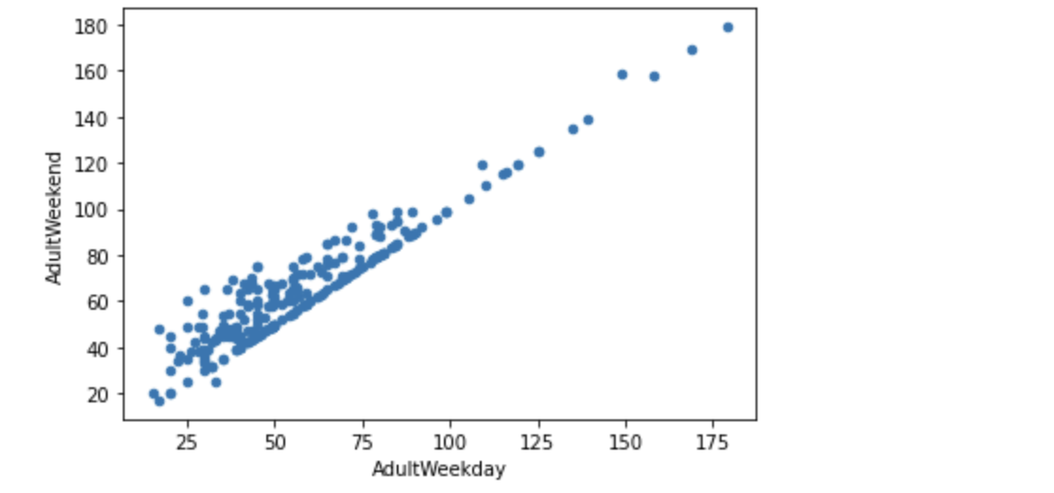

Big Mountain Resort currently charges 81 dollars. The analysis showed that, considering Big Mountain's facilities, a modeled ticket price that could be supported in the marketplace is 95.87 dollars. The big difference between the modeled price and the current price charged shows how much the resort is undercharging.

The business’ shortlisted options were considered to determine if they would impact ticket prices and the following were concluded:

1. Closing the least-used runs provides varying levels of support for ticket pricing, the best of which is not making any difference at all, if only one run is closed as shown in the graph below:

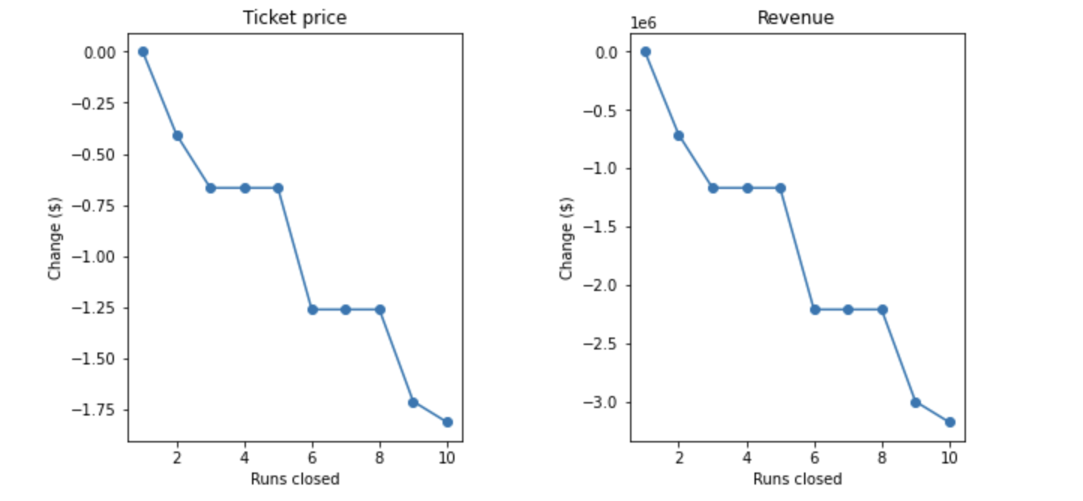

1. Increasing the longest run by 0.2 miles would have no effect on the ticket prices.
2. Adding a run to increase the vertical drop by 150 feet, and installing an additional chair lift would be the best possible scenario to aid a market-supported ticket price. Based on the assumption that each visitor buys an average of five day tickets, this suggested price raise will cover for the operating cost of the new chair, since customers tend to pay more for certain facilities and less for others.
3. Going further to add two acres of snow making would not make much difference either.